2 A chat with ChatGPT

This chapter covers
- Accessing the GPT Web interface
- Using GPT directly for data processing
- Using GPT indirectly for data processing
Please ignore grammar errors and typos. What you see is a raw manuscript; it has not been copyedited.
Time to meet GPT! In this chapter, we will have a chat with GPT and start using it for data analysis. If you have never used GPT, this chapter will teach you how to access GPT and give you a first impression of its capabilities (as well as its limitations). If you have used GPT but not yet for data analysis, this chapter will show you some of the many ways in which we can exploit GPT in this context.
In the following, we will first discuss a Web interface giving you access to ChatGPT, one of the most popular GPT variants. We will go over the registration process, discuss the main functions offered by the interface, and use it to have a first dialogue with ChatGPT. After that, we will start using GPT to analyze data in a few example scenarios. We will see two different ways to exploit GPT for data analysis: directly and indirectly. If using GPT directly, we apply GPT to do the actual data processing, given data and a task description as input. This works for data types that GPT processes natively, in particular text data. On the other hand, we can also use GPT to analyze data indirectly. Here, GPT merely serves as a translator, translating descriptions of analysis tasks into formal languages that are understood by external data processing tools. The actual data processing is then handled by those external tools. In this chapter, you will see that GPT is useful in both scenarios.

2.1 Accessing the Web interface

Figure 2.1 Start page of OpenAI’s ChatGPT interface before logging in. Click on the Signup button to create an account.
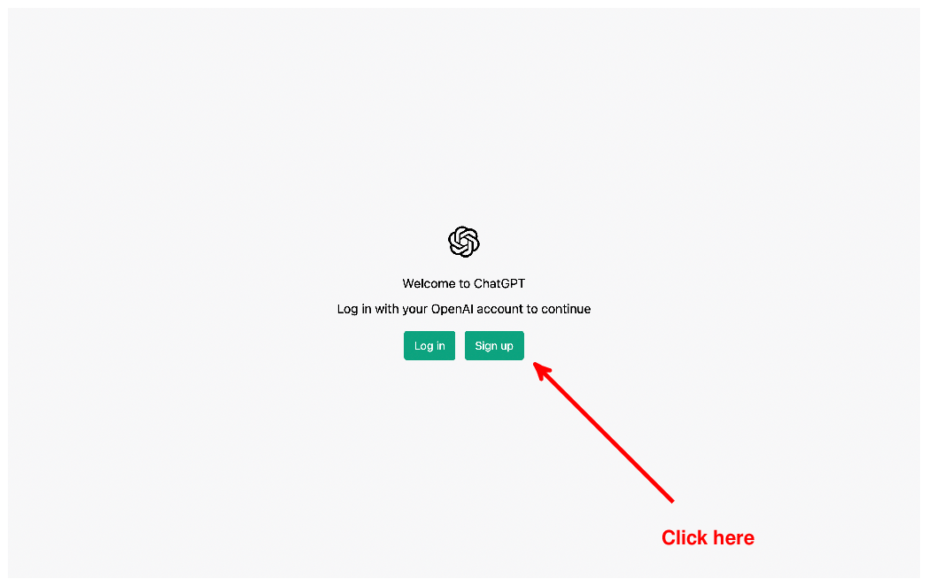

Up – Understood.
Open your Web browser and type https://chat.openai.com/ into the address bar. You will see the Web site depicted in Figure 2.1. Next, we will create an OpenAI account that enables you to use ChatGPT. If you already have an account, you can skip the following steps, log into your account, and proceed with the next section directly.

GPT versus ChatGPT
OpenAI offers various different “flavors” of the GPT model, specialized for different tasks and realizing different tradeoffs between procesing time and output quality. ChatGPT, as the name suggests, is a model version specialized for dialogues with users. At the same time, as we will see in the following, ChatGPT is versatile enough to solve a variety of tasks as instructed by users.

Figure 2.2 Signup page for OpenAI account. Enter your email address (Email field) and click on the Continue button (Continue) or sign up using a Google account (Google Login) or a Microsoft account (Microsoft Login).
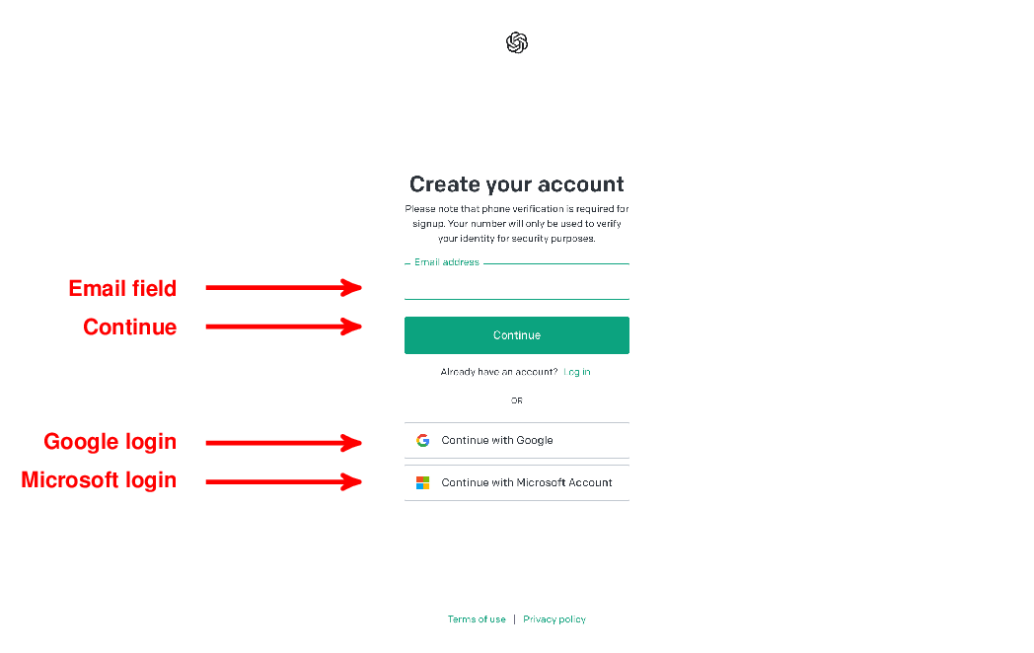

Up – Understood.
To create an account, click on the Signup button (marked by the arrow in Figure 2.1). This brings you to the screen depicted in Figure 2.2. You have several options to sign up for an OpenAI account:
- Sign up using a Google account (by clicking on “Google login”).
- Sign up using a Microsoft account (by clicking on “Microsoft login”).
- Sign up with an arbitrary email address by entering that address into the “Email field”, then clicking on “Continue”. After that, follow the instructions given on screen.
After creating your account using any of the aforementioned options, log into your newly created account and continue with the steps outlined in the next section.

OpenAI Subscriptions
Note that OpenAI offers different types of accounts, some of them are free whereas others come with a monthly fee. For the following examples, a free account is entirely sufficient. You may still choose to sign up for the paid subscription to gain access to more models and to get faster answers from GPT. Depending on which subscription you choose, your screens may look slightly different from the following screenshots.
Any comments on section 2.1 Accessing the Web interface?

Up – Understood.

2.2 Making Introductions

Figure 2.3 ChatGPT Web interface: interact with ChatGPT by clicking on pre-defined example inputs or enter arbitrary text into the input field. Click on the “New chat” button to reset the conversation.
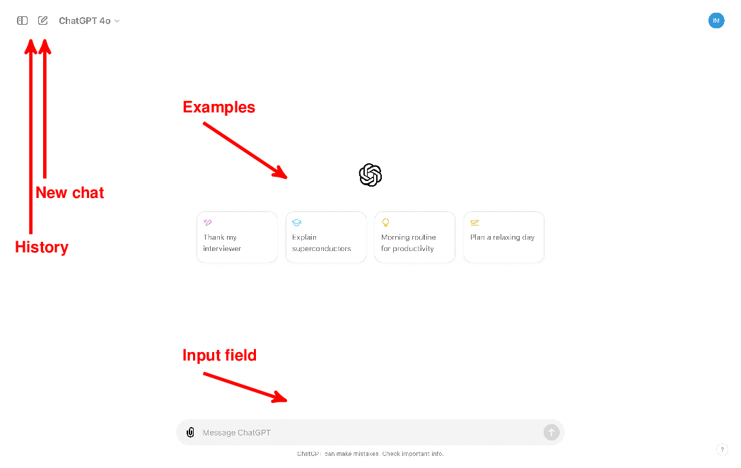

Up – Understood.
After logging into your OpenAI account, you should see the interface depicted in Figure 2.3. This interface enables you to have a dialogue with ChatGPT by submitting text input and receiving answers. Let’s take a moment to understand the most important interface components in Figure 2.3. First of all, you have a couple of pre-defined input examples (“Examples”). You can simply click on any of those examples to get the conversation started! Besides pre-defined examples, you have the option to enter arbitrary text into a text field. We will refer to this interface element as the “Input field” in the rest of this chapter. Finally, at any point, you have the option to start a new conversation via the “New chat” button. Doing so erases ChatGPT’s memory of all prior dialogue steps.
Time to say hello! Click on the input field and say hello to GPT! You can really type anything. GPT has been trained to conduct dialogues with human users and should be able to answer most inputs in a reasonable manner. For instance, tell GPT a little bit about yourself! Ask for opinions or for help with any upcoming tasks! Or, perhaps, ask it to write a little poem about a topic of your choice! You might want to spend a few minutes chatting with GPT to get a better sense of its capabilities as well as its limitations.

Figure 2.4 After ChatGPT generates an answer, the “Regenerate Response” button appears below the generated response. Click on this button to receive an alternative answer to your last input.

Good description of setup but as AI continues to quickly evolve, so will the interfaces. Readers should be forewarned and advised to refer to website if things appear different between the book and their computer screens.

Note that GPT can refer back to prior inputs. For instance, if you are not satisfied with a prior reply, you may ask GPT to correct or to change it. No need to repeat the original request! Also, if you are not satisfied with an answer but do not want to provide further clarifications, try the “Regenerate response” button (see Figure 2.4). Clicking that button will cause GPT to regenerate its last answer. As GPT uses a certain degree of randomization while generating output, chances are good that the second output is different (and, possibly, better) than the first version.
Typically, all text you enter is part of the same conversation. If, at any point in time, you want to start a new chat (essentially erasing GPT’s “memory” of the prior conversation), simply click on the “New chat” button (see Figure 2.3). Note that prior conversations are not lost, even when starting a new one. Instead, OpenAI stores past conversations and enables users to go back and study them (or to continue the conversation from where it ended last time). You can access a history of prior conversations by clicking on the corresponding buttons (see Figure 2.3). Each conversation is assigned to a short title, generated automatically based on the conversation content.
Using ChatGPT for the first time is often an impressive experience. ChatGPT generates polished and reasonable answers for a variety of topics. This may mislead users to put too much faith into the information it provides. It’s important to avoid losing sight of the various limitations that apply to the current generation of language models. In general, always verify output of the language model before relying on it.

What are hallucinations?
The term “hallucination in language models” describes precisely the behavior we’re seeing in our example. It refers to situations in which language models invent new content, in the absence of information, and integrate it into their answers. Quite often, the result sounds convincing and it can be hard to recognize instances of hallucination. Ongoing research explores methods to reduce the chances for hallucination. However, at the time of writing, no reliable strategies to avoid hallucination are known yet. Hence, don’t trust information from language models blindly but always use alternative sources for corroboration. If you are interested in learning more about hallucination in language models and research in this area, have a look at the recent survey on the topic by Ji et al.
Any comments on section 2.2 Making Introductions?

Up – Good intro.

2.3 Processing text with GPT
Let’s start using GPT for data processing! In this section, we will use GPT for analyzing text, a common type of unstructured data. At the same time, text is the native input and output format of ChatGPT. This means we can use GPT directly to analyze our (text) data, without involving external analysis tools. That helps to keep things simple and that’s just what we want for our first steps towards GPT-supported data analysis.
Imagine the following situation: you’re an employee of Banana, a producer of various consumer electronics, including laptops and smart phones. The Banana Web site enables users to post free-form text comments. It turns out that many users comment on their satisfaction or dissatisfaction with specific Banana products. Quite often, users point at specific aspects of these products that stand out or need improvement. In aggregate, all those reviews should be very helpful to inform the design of future Banana products! But to make that possible, we first need to analyze all of them and extract common points. Your boss asks you to do just that, preparing statistics that summarize reviews for different products and product categories. And, while you’re at it, reading through reviews, your boss encourages you to write a few nice replies to the product reviews as well. Ideally, you want to avoid spending your next weeks reading and aggregating reviews. Can’t we automate that? Perhaps GPT can help.
In the following, we’ll use the ChatGPT Web interface to analyze an example review. If that works well, it may be possible to scale up the process to automatically analyze all of them! If you have started a dialogue previously, first hit the “New chat” button to start a new conversation. This will make sure that the topics you discussed with ChatGPT previously won’t interfere with the analysis examples we try next.
Let’s start by telling ChatGPT about the review that we want to analyze! Click on the input field and enter the text after the “User” marker in the following dialogue, then hit enter.
The text after the “GPT” marker is the answer generated by ChatGPT during a sample session. In this case, ChatGPT simply repeats the review, albeit with a slightly different wording, demonstrating that it has accepted and “understood” your input. Note that you may get slightly different text. This is due to the fact that ChatGPT uses a certain degree of randomization when generating text.
Let’s start our text analysis with a simple classification, mapping the review to one out of multiple given categories. Specifically, we will try to classify the review into one of three product categories: mobile phones, personal computers, and game consoles.
Not bad! ChatGPT has clearly understood the task and provides us with a detailed reply. The BananaBook is a fictitious device and it’s not immediately clear what type of product we’re talking about. However, as ChatGPT rightfully points out, coding and office work is most typically associated with personal computers (more so than with mobile phones or game consoles). Despite the uncertainty, ChatGPT is able to come up with a reasonable answer and justify it thoroughly! In this instance, the answer by ChatGPT is even more fine-grained than required: while ChatGPT links the review to one of the three provided categories, it additionally hypothesizes that the review refers to a laptop (a sub-category of personal computers). This assumption seems reasonable in this context, given that the user carries the computer regularly (which is typically associated with laptops, rather than desktop machines).
The answer above is reasonable but maybe a bit lengthy. In fact, its length is similar to the original review. No point in using ChatGPT for text analysis if the resulting answer is of similar length as the source text! Let’s ask ChatGPT to be a little more concise. No need to provide a detailed justification. Rather, we want to get the name of the most likely category of the review alone.
That’s much better! Clearly, ChatGPT was able to understand our instructions and adapt its prior answer accordingly. Besides being faster to read, the concise output has another advantage. If, ultimately, we want to analyze many reviews, as opposed to a single one, it is important to have homogeneous output across reviews. For instance, having homogeneous output makes it easier to count the number of reviews in each of the three categories.
Let’s classify the review according to different categories. This time, we will directly hint at the desired output format (note that our specification “answer concisely” refers back to the previous instructions).
Perfect! That is the right category and the output format is as expected. So far, we have seen that GPT is able to classify reviews according to different criteria. This seems useful, for instance, to create statistics counting the number of reviews in each category. But, ideally, we also want to analyze the content of those reviews. Which products or product categories need improvement most urgently? To determine that, we need to know whether reviews are positive or negative, i.e., whether the user is satisfied or dissatisfied with the product. This is yet another way to categorize the review text. However, this time, our classification does not refer to the product being reviewed but to the review content.
Yes, that’s correct! Using the combination of the capabilities seen so far, we could already use GPT to count the number of positive and negative reviews for different product categories. This gives us some information on which product categories are in urgent need of improvements but that may not be specific enough. For instance, it may be interesting to find out what aspects of a product users are most happy or unhappy with. Let’s try using GPT to extract this information as well!
Correct again! ChatGPT extracts the most salient advantages of the product, mentioned in the review. Note that the output format complies again with the corresponding instructions: it’s a numbered list and each entry has at most three words. How about the drawbacks mentioned in the review?
Indeed: the only drawback of BananaBook is the weight, according to the user. Note that ChatGPT sticks to the requested output format (a numbered list), even though the result only contains a single entry.
Classifying reviews and extracting specific strengths and weaknesses works great if we want to aggregate reviews into statistics. However, doing so may discard information, e.g., a more detailed justification for why users do or do not like specific aspects of a product. Sometimes, we might just want to read through a review sample. To avoid spending time reading overly long reviews, it would however be great to summarize those reviews first. Let’s use GPT to do so.
The result is a reasonable summary that uses precisely the number of sentences requested in the instructions. Can we get it even more concisely?
Yes, that works as well! After initial testing, it seems that GPT may be helpful to automate various analysis tasks indeed. Finally, let’s see whether we can exploit it for tasks beyond mere analysis. Maintaining good customer relationships is a priority for Banana! Hence the question from your boss, asking you to write friendly answers to the user comments wherever possible. But doing that takes time as well! Can’t we use GPT to automate that step, too? Let’s see ...
Pretty good! GPT answers with a friendly message to the customer, referencing specific points in the review in the appropriate manner (confirming positive points mentioned by the customer while promising improvements with regards to the weaknesses). Note that GPT leaves a placeholder for the name of the corresponding company (marked by square brackets). So far, we haven’t told GPT the name of our company (Banana) yet. Let’s fix that.
Ok, that works! Based on the additional information, GPT was able to substitute the placeholder in the previous answer (the name of the company).
We have seen that we can use ChatGPT for a variety of tasks in text processing. Namely, we have used ChatGPT for categorizing text based on different criteria and using custom categories (classification according to review target and according to review content). We have also used GPT to extract specific pieces of information from text and to summarize text. Finally, we have even used GPT to generate text answering a customer review. In all cases, GPT was able to follow instructions with regards to the task and the desired output format. If you want, try writing a different review and make sure that GPT is still able to solve all of the aforementioned tasks!
Until quite recently, the different text processing tasks we discussed in this section would each have required a specialized language model. The latest generation of language models is flexible enough to solve a variety of tasks, merely based on a description of the task in plain English (as well as other natural languages).
Note that we have processed only one short review so far. Here, using GPT does not really provide a benefit. We could have classified or summarized the review manually and be done much sooner than with the help of GPT! Of course, the goal of automation is to scale processing up to a large number of (possibly longer) reviews. If we’re talking of hundreds, perhaps thousands of reviews, manual analysis will take much longer than setting up GPT to do the task. But one crucial component is still missing: how do we go about informing GPT about all the review text? Can we simply copy and paste the whole collection of reviews into the GPT Web interface?
That approach won’t work. Models like GPT come with restrictions in terms of the amount of information they can process at once. For instance, for ChatGPT, the maximal amount of text the model can consider is limited to a few pages of text. Hence, we need a mechanism that automatically “feeds” single reviews (or small collections of reviews) to GPT for processing. We will discuss corresponding approaches in the following chapters. For now, we just want to verify that ChatGPT can be used, in principle, to perform a diverse range of analysis tasks on text documents.

What are tokens?
If you read descriptions outlining the capabilities and limitations of different models (including GPT models as well as language models of other providers) you may come across the term “token”, used to measure the maximal size of input a model can process. This metric is more common (and more precise) than the number of pages we used previously. For the moment, think of tokens as the atomic unit of the text representation, used by the model internally. We discuss tokens in more detail in .
Any comments on section 2.3 Processing text with GPT?

Up - Good variety of examples.

2.4 Processing tables with GPT
In the last section, we used GPT directly for data processing, providing GPT with data as well as a task description as input. This approach is reasonable as long as we’re processing text, the “native” input and output format of ChatGPT. For other types of data, it is much more efficient to use specialized, data type-specific tools for data processing. Now you might be wondering: if we process data with external tools, how can GPT still be helpful in this context?
There are many tools for processing data, specialized for different types of data, processing, and hardware or software platforms. To use such tools, users often need to express the desired analysis operations in tool-specific formal languages. Writing code to analyze data can be tedious, for experts and even more so for users with limited IT background. Here, language models like GPT can help since they understand natural language as well as formal languages used for a variety of data analysis tools. This means we can use GPT as a sort of “translator”, translating our questions about the data, formulated in plain English, into code in various languages, to be executed via external tools. This is what we will do in the following.

Table 2.1 Example table with three columns, representing the review ID, a flag indicating whether or not the reviewer is satisfied with a product, and the product category.
1 | 1 | Laptops
2 | 0 | Phones
2 | 1 | Gaming
... | ... | ...
We’re back at Banana and have successfully used GPT to analyze all the various reviews submitted by users. It is quite natural to represent this information as a data table. Each row corresponds to one review and different columns represent different types of information we extracted from the review. Have a look at Table 2.1 which illustrates this table, showing the first few table rows. To keep the example simple, we use a table with few columns, corresponding only to a subset of the analyses described in the previous section. The first table column contains the review ID. The second column contains a flag indicating whether the reviewer is satisfied with the product (1) or dissatisfied with the product (0). The final column contains the category. For this example, we consider only three categories: laptops, phones, and gaming.
This table is already a much more concise representation of the original reviews. But still: the full table has many rows (since we started out with many reviews) and reading the raw table data is not very insightful. Ideally, we want to aggregate data in interesting ways and present only the high-level trends to our boss. Which tools could we use to do that?

2.4.1 Processing tables in the Web interface

Figure 2.5 Click on the “Upload button” and choose the option “From computer” to upload files on disk.
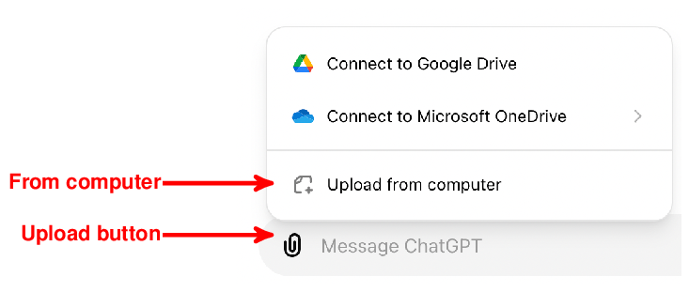
Up – Understood.
The first option is to use the OpenAI Web interface directly for analyzing tabular data. First of all, let’s download an example table with the review analysis results. Search for the link named “Review Table” on the book’s Website. Download the associated file. It contains a table of the structure shown in Table 2.1 in .csv format.

What is the .csv format?
CSV stands for “Comma-Separated Values”. It designates a specific format used to represent tabular data. Each table row is stored in a separate line and values for different columns in the same row are separated by commas (alternatively, despite the name “CSV”, other delimiters such as tabs can be used).
To analyze such data directly in the GPT Web interface, we first need to upload it. Click on the “Upload” button, shown in Figure 2.5. Choose the option “From computer” and select the file you just downloaded (“reviews_table.csv”). After uploading the file, it should appear next to the input text field, shown in Figure 2.6.

Figure 2.6 After uploading files, they should appear next to the text input field.
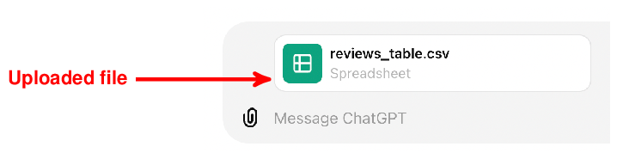
Up – Understood.
You can now enter arbitrary questions about the data into the input text field. When generating its answers, GPT will take into account and analyze the data you provided. For instance, let’s ask about the number of reviews for each product category:
You should see output like the one shown in Figure 2.7: GPT shows a table containing the answer to your question (each row counts the number of reviews for one product category) and an accompanying text. How did GPT calculate the answer? Did it read the entire table to generate the reply directly? Not quite. In the background, GPT generates and executes Python code on OpenAI’s platform that analyzes the input data (in this scenario, the Python execution engine is the “external tool” we referred to initially). You can see the generated code by clicking on the “Show analysis” button in Figure 2.7. In fact, it is highly recommended to check the generated code before relying blindly on an answer. After all, despite their amazing capabilities, language models do regularly make mistakes.
Try out a few more questions, check the generated code, and possibly even try out a few different data sets (you can upload any tabular data on your computer, e.g., in Excel format)! You will find that GPT is able to handle a variety of data sets and requests.

Figure 2.7 Answer generated by GPT for a question about the input table. Click on the “Show analysis” button to see how GPT calculated the answer.

Up – Understood.
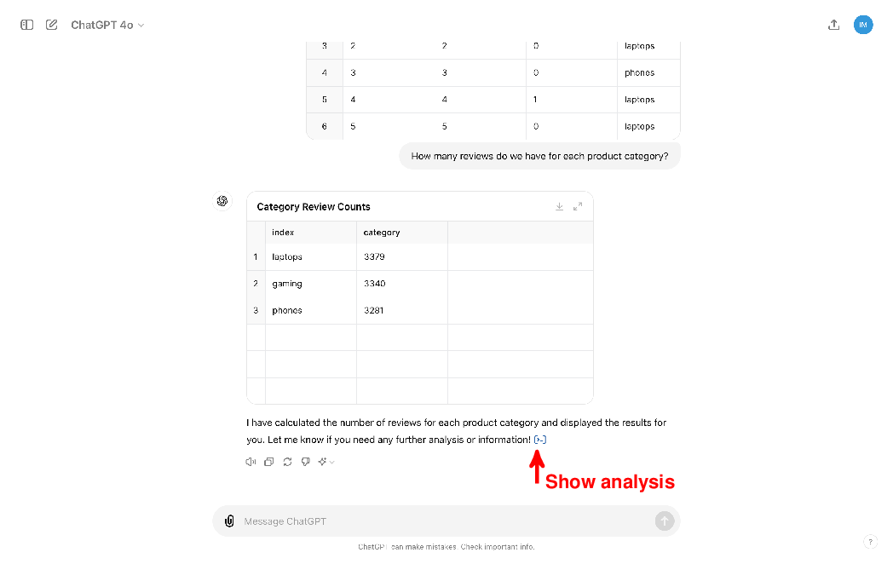

Up – Understood.
This seems to work pretty well! Why do we need anything else? Well, there are a couple of reasons why we would like to explore other external tools for data analysis. First of all, there are strict limits on the size of files we can upload (512 MB at the time of writing). Uploading large data sets is not possible. Second, you might have noticed that data analysis with Python might well take a few seconds, even for moderately sized data sets (e.g., the table with reviews has only 10,000 rows, rather small according to today’s standards). Analyzing large data sets takes prohibitive amounts of time. Finally, uploading data to OpenAI may not be acceptable for each use case. To preserve privacy for sensitive data, users might prefer analyzing data on their own platforms. In the next section, we will see how we can use GPT to analyze data outside of OpenAI’s Web interface.

2.4.2 Processing tables on our own platform
In some scenarios, analyzing data directly in OpenAI’s Web interface is not an option. Instead, we can leverage GPT to help us use various other tools for data analysis that are directly under our control. In the following, we will use a relational database management system (RDBMS). Such systems are specialized for handling data of the type we’re interested in and tend to achieve high processing efficiency. This is just an example and the proposed approach generalizes to various other types of data analysis systems as well.
A relational database management system is specialized for handling relational data, i.e., data sets that contain one or multiple tables of the type we have in Table 2.1. Most of them supported variants of the structured query language (SQL), a language used to describe data and operations on data. In the following, we will assume that you are familiar with the basics of SQL and relational database management systems. To brush up on your SQL skills, have a look at the book by Gehrke and Ramakrishnan or try the online course by this book’s author at www.databaselecture.com.

Figure 2.8 Google Colab notebook allowing you to query the BananaDB database via SQLite. Execute the upper cell (“Create database”) to create the database, replace the given SQL query (“SQL query”) by one of your choice, then execute the lower cell (“Execute query”) to see the query result. The arrow marks the “Run” button used to execute the upper cell.
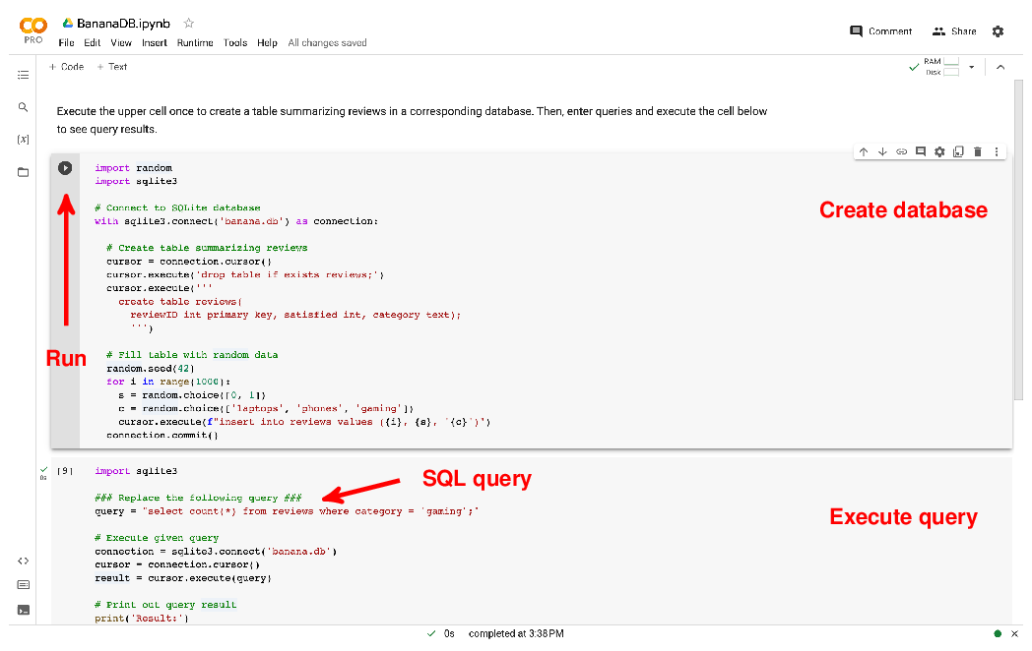

Down – Link to notebook not provided.
More precisely, we will use SQLite, one of the most popular RDBMS in the following. To save you the headaches of installing and configuring that system on your own machine, have a look at the book Web site and follow the link to the [BananaDB] resource. It will lead you to a Google Colab notebook that you can use for the following steps. Figure 2.8 shows the notebook that you should see after following the link.
We will use Google Colab notebooks throughout this book to facilitate following examples without installing software on your local machine. The following explanations assume that you’re familiar with Colab Notebooks in general. Have a look at the excellent tutorial on the topic by Google at https://colab.research.google.com to brush up on your notebook skills.
The notebook already contains code for creating an example database and for analyzing data within it. This chapter is about getting the hang of GPT’s Web interface. Hence, for the moment, we will not spend time discussing the code in the notebook in detail. For the rest of this chapter, it is sufficient to know what the code is doing and which specific parts of it you need to change in the following. At a high level of abstraction, the code in this notebook creates a database with example data and allows you to execute SQL queries analyzing it via SQLite.
You see two cells containing code in the notebook (marked as “Create database” and “Execute query” in Figure 2.8). The upper cell (“Create database”) contains code that creates a database containing an extended version of Table 2.1, filling it with data about 1,000 reviews. Let’s execute that cell first by clicking on the “Run” button, at the left upper corner of the cell and marked by an arrow in Figure 2.8. After a couple of seconds, this should create an SQLite database and fill it with corresponding data. You only need to execute this cell once per session. If, however, you do not interact with the notebook for a sufficiently long amount of time, the environment will be reset and you need to execute the cell once more.
In the following, we will ask ChatGPT to write SQL queries for us that refer to this database. You can execute SQL queries on that data using the lower cell (“Execute query”), shown in Figure 2.8. By default, the cell contains an SQL query counting the number of reviews in the “gaming” category. Execute the cell (by clicking on its run button) to see whether everything is working. You should see the number 342, counting the number of reviews in the “gaming” category, after executing the cell. We will replace the current query (select count(*) from reviews where category = ’gaming’;) by the queries proposed by ChatGPT in the following, then re-execute this cell to get the results for the new queries.
Okay, time to have ChatGPT do some data analysis for us! First of all, start a new dialogue by clicking on the “New chat” button in the ChatGPT Web interface. This is important to make sure that prior dialogue steps do not interfere with our new task. To use GPT for writing queries, we first need to tell GPT a little bit about how our database looks like. In particular, we should describe the table structure, meaning the name of the table (Reviews) and all associated columns. In this case, the table has three columns and we probably should add a little bit of text about the content we have in those columns. When writing SQL queries, it is particularly useful to know a little bit about the types of data we find in each column, ideally some information on the specific values we might find and about their semantics as well.
Finally, another important piece of information is the specific system we use for analyzing data. While many RDBMS support SQL and SQL is fairly standardized, the specific subset of supported SQL features may differ across systems. Furthermore, some of these systems may support SQL syntax that slightly deviates from the SQL standard.
Having clarified which information matters for writing SQL queries, let’s provide GPT with that information for our BananaDB example database!
GPT is upbeat about the prospect of analyzing our database and answers with a summary of the database structure that we provide in our input. Also, GPT already has a sense of where this is going and proactively proposes to write some example SQL queries before we even ask for it! Let’s see what GPT has in store.
Not bad! The queries cover quite a few natural questions, e.g., on the number of reviews that fall into specific categories. In general, asking GPT to propose queries is not a bad way to start analyzing a data set.

Figure 2.9 The ChatGPT Web interface uses specialized markup to represent code, including SQL queries. Click on the button marked by the arrow to copy the code (making it convenient to paste the code into suitable interfaces for execution).
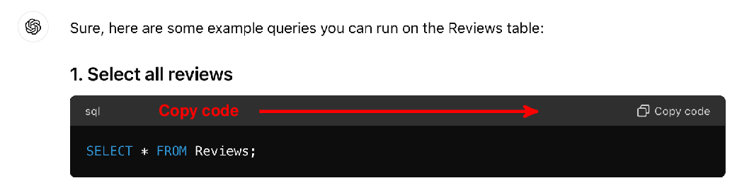
Up – Understood.
You may notice, by the way, that the Web interface displays SQL queries using a specific representation. Figure 2.9 shows how the first of the aforementioned queries is displayed. The SQL query is included in a box, making it easy to copy it by clicking on the button marked by the arrow in Figure 2.9. To try out any of the proposed queries, copy it (as described before), then insert it at the appropriate position within the BananaDB notebook (“SQL query” in Figure 2.8). Finally, execute the surrounding cell in the notebook to obtain the query result.
Let’s see whether we can make GPT translate our own questions into queries as well.
We are interested in finding the product category associated with most reviews. Indeed, GPT translates our question into an SQL query that retrieves the corresponding result. If you execute this query on our example database, it should retrieve the “gaming” category, along with the number of associated reviews. Note that this is the first multi-line SQL query generated by GPT. To use that query in our Colab notebook, surround the query with triple quotes ("""), rather than single quotes. Doing so ensures that the entire query is treated as a single string.
Strictly speaking, we only asked for the category but not for the associated count. Here, GPT takes some liberty by adding the count to our query result. In this case, that may be acceptable and even interesting. In general, if using GPT to translate questions into queries, make sure that GPT does not expand your queries in ways that are not acceptable (e.g., if the output is forwarded to another tool that expects a specific input format). Let’s see whether we can make GPT follow our instructions more tightly.
Perfect! GPT has slightly rewritten the previous query to return only the category, but not the associated count anymore. You may notice that GPT’s answers contain the query but also an explanation for why the query does what it is doing. Such explanations are helpful to verify that queries generated by ChatGPT are indeed correct. Next, let’s drill down a bit further and see which ratio of reviewers were satisfied with their gaming products.
Executing this query, you should find that a ratio of around 50% of reviews is positive (i.e., the corresponding reviewer is satisfied)¹. Finally, let’s see which product category needs improvements most urgently.
Executing this query should return the phones category, together with the associated ratio of positive reviews.
In this section, we have seen a second way to use ChatGPT for analyzing data: instead of applying GPT directly to the data, we rather use it as a translation mechanism. In this case, we translate questions about the data (formulated in plain English) into SQL queries that we can then execute using a corresponding tool (a RDBMS in this scenario). In future chapters, we will use it to translate to other formal languages, besides SQL, as well.
Again, we have entered questions by hand, then copied our queries to a different interface. This approach is clearly not the most convenient one. In future chapters, we will see how to build frameworks that automate all of those steps.
Any comments on section 2.4 Processing tables with GPT?

Up - Good explanations given.

2.5 Summary
- Language models can solve various tasks, given instructions in natural language.
- While powerful, language models can produce incorrect output.
- ChatGPT is a popular language model, produced by OpenAI.
- You can use ChatGPT via a Web interface in your Web browser.
- To process text with ChatGPT, enter the text and a task description.
- ChatGPT can classify text, given classification categories.
- ChatGPT can extract information from text, given corresponding questions.
- ChatGPT can produce text summaries according to user specifications.
- ChatGPT is not suitable to process large data sets directly.
- However, ChatGPT can generate code that processes large data using other tools.
- To produce code, enter a description of the data, the task, and the output format.
- We will see more powerful APIs to access ChatGPT in later chapters.
¹ That is not surprising, given that our test data is generated with uniform random distribution (i.e., the number of positive and negative reviews should be approximately equal).↩︎
What did you think of this chapter?
hide feedback

1
How many stars would you give this chapter?
4

2
What is your overall impression of this chapter?

Good explanations. Examples emphasize the wide range of questions the LLM can answer.

Hrlpful
sitemap
Prev Chapter
Next Chapter
Up next...
3 The OpenAI API
- Installing the OpenAI client
- Invoking GPT using Python
- Configuration parameters

